SAFETY ALERT

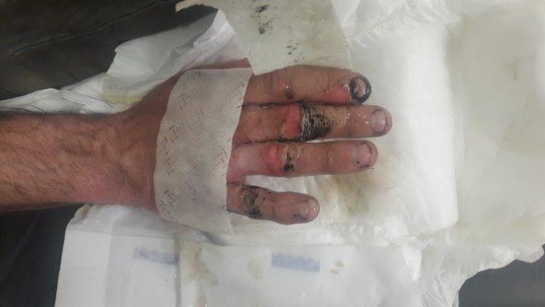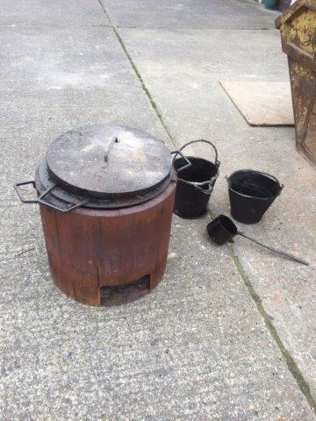

Recently on one of our sites we had an incident involving one of our sub-contractors, who was carrying out minor edge sealing of existing reinstatement snags. Prior to the works commencing, the contractor opted to heat up his Bitumen Boiler to speed up the works and while doing so, removed his fire retardant gauntlets. The boiler spewed out some hot tar which struck him on the hand resulting in injuries as shown in the attached picture. While he was treated immediately, using our first aid kit, this resulted in him having to attend hospital for further dressing and monitoring. Thankfully he will make a full recovery with no scarring.

The purpose of this alert is make all site management teams aware of the dangers of this piece of equipment (pictured) and to ensure all hot works permits conditions are followed, which should ensure full PPE is worn always to prevent a recurrence of this type of injury. If in any doubt, please contact the HSEQT team*.*